**Sports Finder App**

Project Proposal

Nottingham Trent University

Final Year Project

Contents

Introduction 3

Aims and Objectives 3

Task and deliverables 3

Gantt Chart 3

Resources 3

Risks 3

Legal, Social, Ethical and Professional Issues (LSEPIs) 4

# Introduction

1. Explain the topic and give a general overview to the project.
2. Demonstrate familiarity with the background literature.
3. Identify a problem(s) which is relevant to the topic
4. Place the topic in a wider context.
5. Identify any general implications for the project

The project I will be proposing is a sports app aimed at people who may have some interest in sports between all ages. The aim for this app is to get more people involved with sports and help them find opportunities near them depending on the sports they have interest in (i.e. sport centres, clubs etc).

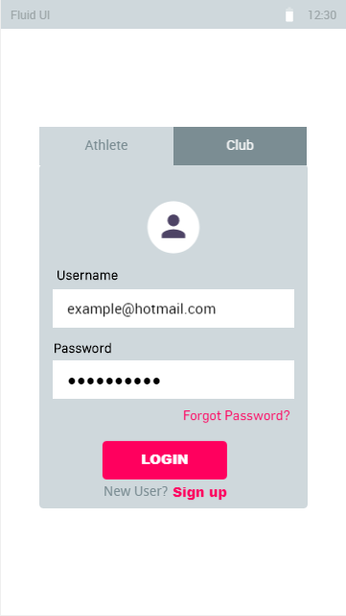 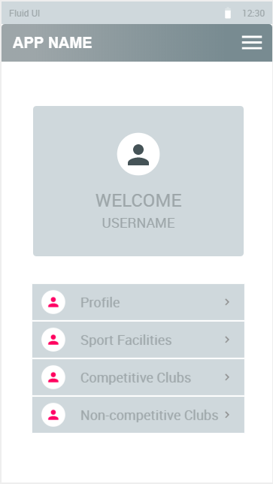 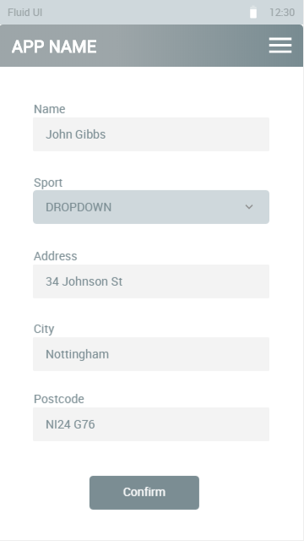

Using this app, the users’ will have the abilbity to search for clubs or find oppertunities around their area. You can filter out the competivite oppertunities with non competitve ones depending on the user’s peference. They will also have the option to fliter clubs depending on the sport they have chosen in the dropdown field they will be provided. Upon start of the app, the user will be presented with a login interface. They will be able to login if they already have a account registered, alternatively, they will be given an option to sign up.

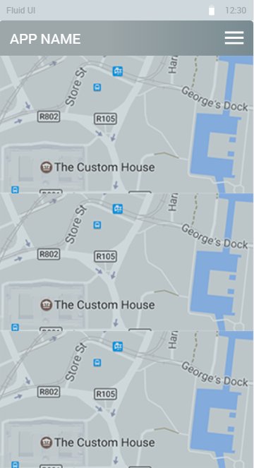 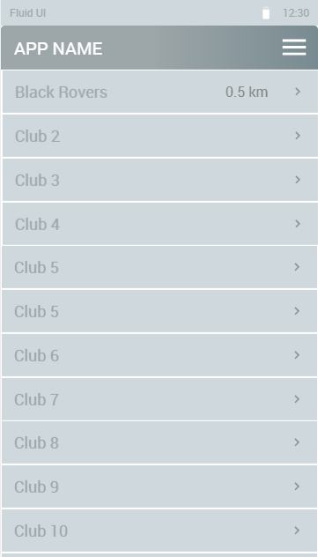 

Pic. 4 Pic. 5 Pic. 6

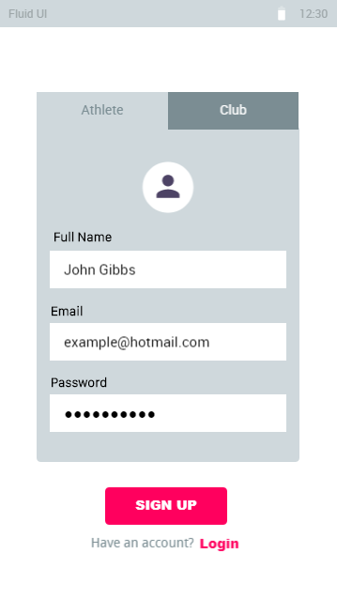 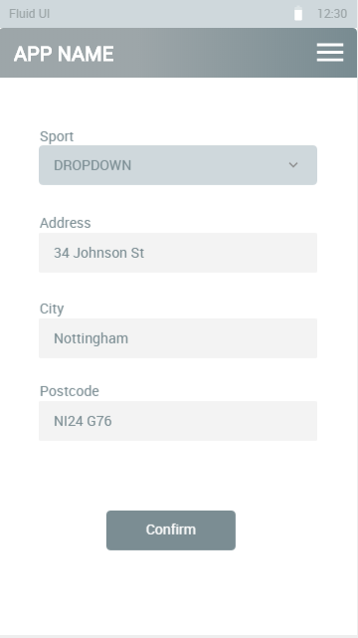 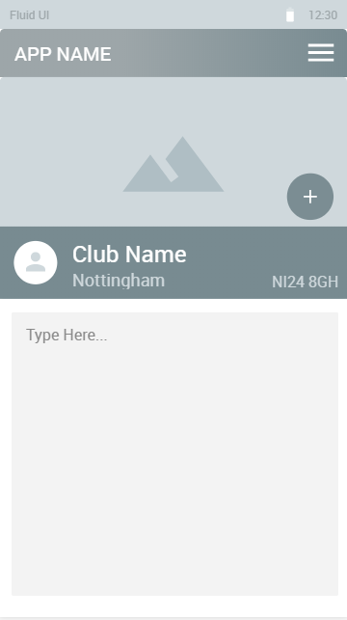

# Aims and Objectives

Describe what this project will attempt to achieve and deliver. You will need to state clearly the aims and objectives of the project. Your objectives must follow the SMART (Specific, Measurable, Achievable, Realistic and Time Bound) methodology.

# Task and deliverables

Identify the tasks that need to be carried out in order to complete this project. Outline the expected outcomes that this project hopes to deliver. Provide details of the expected scope of the project and which of the tasks and deliverables may or may not be within scope. List the main project milestones.

# Gantt Chart

The Gantt is a graphical representation of the tasks and deliverables listed above as well as other timed commitments you have in your final year. It is a useful tool in managing your time in your final year.

Some of the milestones are certain. These include the review points and the assessment deadlines. Other timings are less certain. For example, which tasks to complete first and how long it will take to complete them. If you follow the Agile methodology when working on your project, then you will regularly review the tasks and timescales. For the purposes this planning document your Gantt chart needs to include the initial timings for:

* 1. Project milestones (including main deliverables)
  2. Project tasks and deliverables including start time and duration
  3. Other milestones including deliverables for other modules, exams etc.

# Resources

In order to work on your project, you will require various resources such as software and hardware, literature and research findings etc. These can come from a wide range of sources including lecturers, colleagues, connections you have made on your placement etc. In this chapter you need to:

* 1. List of the resources that you will use to meet the project outcomes.
  2. List the sources of the information required to conduct the project.

# Risks

Any project will face challenges which may present a significant risk to the success of the project. Some of these risks might be completely unexpected others may be predictable. In this section you need to provide a table of possible risks that could “derail” your project. Some of the risk may be practical or technical, other risks may relate to the intended outcomes of the project itself.

In each case you need to

* 1. Identify the risk
  2. Explain the cause of this risk
  3. Propose a potential solution

# Legal, Social, Ethical and Professional Issues (LSEPIs)

It is essential that any project considers the Ethical issues that relate to the project. Ethics are the consideration of how your project effects people and society in any way. It is unlikely that your project will not have an impact on the wider society in some way. You need to consider these issues for both the outcomes of the project and for the way in which you carry out your project.

Legal issues: any area of computing related legislation (Data Protection Act, Computer Misuse Act, Freedom of Information, ….)

Social issues: areas that impact on society (home, education, workplace), welfare and surveillance.

Ethical issues: safe guarding (DBS), Health and safety, risk assessment

Professional issues: observing professional competence and integrity by observing the rules, standards and conventions of the profession.

**The importance of this section in your planning document is emphasised by the fact that a failure will result in a failure for the whole PPD assessment.**

* 1. Explain the LSEPI’s that relate to your project outcomes
  2. Explain the LSEPI’s relating to the process of carrying out your project.

Specifically, will the research that you carry out have any effect on people. As well as completing this section in your PPD all students will also need to complete an Ethical Issues Declaration form (submitted with your Review Point 1 form). This form helps to identify if additional Ethical approval is required to carry out your project.

Further information on the BCS code of conduct is available at:

<https://www.bcs.org/membership/become-a-member/bcs-code-of-conduct/>